14.42: a) The cross-sectional area presented by a sphere is 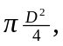therefore 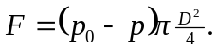 b) The force on each hemisphere due to the atmosphere is 